`

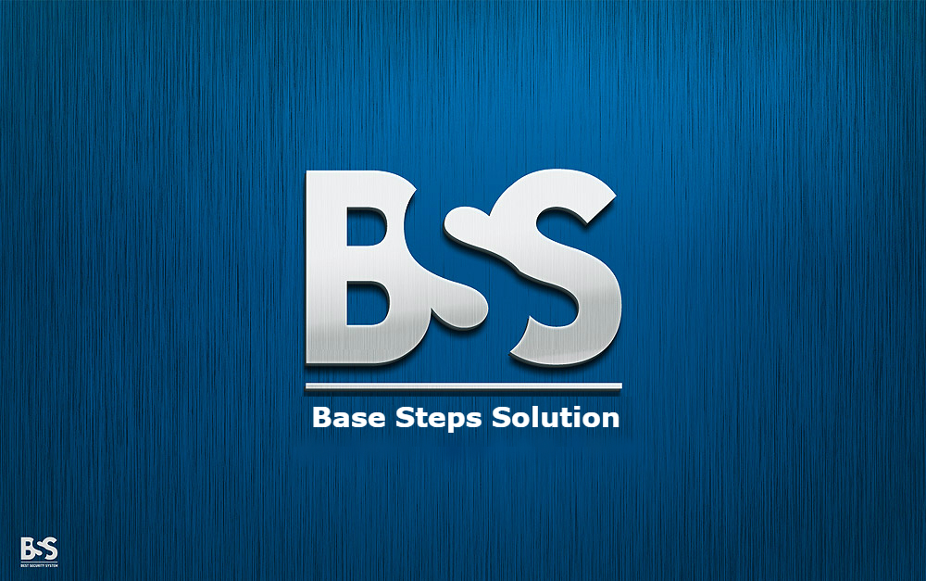

REQUIREMENT DEVELOPMENT PROCESS

Van Lang Admissions

# Revision Table

|  |  |  |  |
| --- | --- | --- | --- |
| Author | Date | Reason for changes | Version |
| Hai Tran | 1/11/2016 | Initial the document | 1.1 |
| Khoi Nguyen | 2/11/2016 | Re-format document | 1.2 |
| Minh Đoàn | 14/11/2016 | Add Schedule | 1.3 |
| Hai Tran | 16/11/2016 | Update process | 1.4 |

Contents

Revision Table 1

1. INTRODUCTION 3

1.1. Purpose 3

1.2. Audience 3

2. Process 4

2.1. Process Activities/step 4

2.2. Activities description 4

3. role and responsibility 6

4. Tools and method 7

5. Goal , question , metric 8

5.1 Goal 8

5.2 Question 8

5.3 Metrics 9

# INTRODUCTION

## Purpose

Software Requirements is a field within software engineering that deals with establishing the needs of stakeholders that are to be solved by software. The IEEE Standard Glossary of Software Engineering Terminology defines a requirement as:

* A condition or capability needed by a user to solve a problem or achieve an objective.
* A condition or capability that must be met or possessed by a system or system component to satisfy a contract, standard, specification, or other formally imposed document.
* A documented representation of a condition or capability as in 1 or 2.
* The activities related to working with software requirements can broadly be broken up into Elicitation, Analysis, Specification, and Management.

## Audience

* The main audiences of this document are: Mentor, Base Steps Solution Team and may be customer of they need.

# Process

## Process Activities/step

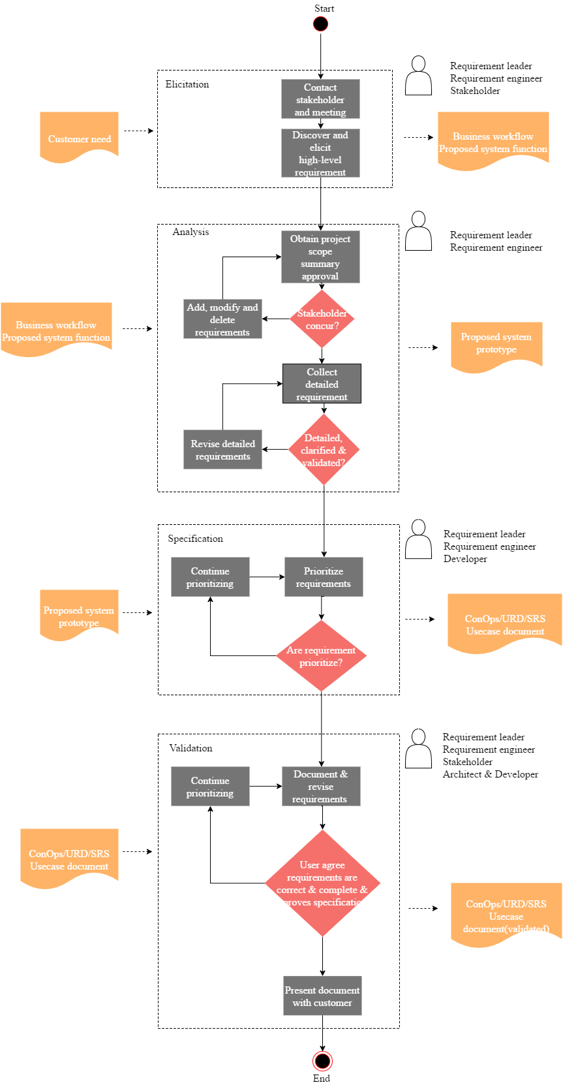

## Activities description

|  |  |  |  |  |
| --- | --- | --- | --- | --- |
| Phase | Objective | Input | Output | Activities |
| Elicitation | Understand business workflow, customer needs  , constraints of proposed system | Customer needs | Business workflow doc  Proposed system function doc with constraint and quality attribute | 1. Identify stakeholder 2. Meeting with customer 3. Gather customer requirement using: Req. E technique |
| Analysis | Analyze customer requirements to offer solutions for proposed system | Business workflow doc  Proposed system function doc with constraint and quality attribute | System prototype  Proposal doc | 1. Define scope of project 2. Identify customer problem 3. Use 4W+ 1H method 4. Review and give priority to requirements 5. Draw prototype 6. Make proposal doc |
| Specification | Specify the requirement into user and developer requirement to implement easier | System prototype  Proposal doc | ConOps doc  URD  SRS  Use-case doc  System prototype | 1. Write Requirement in structure for Customer, Developer and User to understand 2. Make document |
| Validation | Validate with stakeholder(customer) to make sure the requirement is correct | Con-Ops doc  URD  SRS  Use-case doc  System prototype | Con-Ops doc  URD  SRS  Use-case doc  System prototype | 1. Present document with customer 2. Re-evaluate 3. Re-write if needed |

# role and responsibility

|  |  |
| --- | --- |
| **Role** | **Responsibility** |
| Requirement Leader | * Make and manage phase plan * Set up meeting schedule with stakeholder * Prepare template to use in phase * Summarize and release phase document |
| Requirement Engineer | * Agree and apply method, technique to use in phase * Communicate, explore, gather Customer’s requirement * Define perspective of requirement, make prototype * Write document * Prioritize and validate requirement (complete, consistent) * Convert the user Req. to software Req. |
| Stakeholder (customer) | * Meet with team to provide and communicate requirement * Validate the document |
| Developer | * Involve in Specification to provide idea of Software function, help team understand better |
| Architect | * Involve in Specification to provide idea, help team understand better * Ensure the requirement match with scope * Identify the conflict of hardware, software, system |

# Tools and method

|  |  |  |
| --- | --- | --- |
| **Phase** | **Method used** | **Supported tool** |
| Elicitation | * Interview * Questionnaire * Brainstorm * Storyboarding * Analyze existing documents | End-user tool: AnnotatePro! iRequire, ImmerdiateVisualization |
| Analysis | * Prioritize * Use workflow, scenarios * Use dataflow diagram, state diagram * Prototyping (proposed system) * Conduct trade-off | Draw.io, ConTexter |
| Specification | * Prototyping * Use UML, flowcharts, swim lane * Use Use-cases | UML Language program |
| Validation | * Inspection * Review: walkthrough * Prototype | Checklist  Perspective-based reading  Creation of Artifacts |

# Goal, question, metric

## 5.1 Goal

Goals are defined in term of purpose, perspective.

* Purpose: To analyze requirements to understand it and develop it.

- Perspective: Examines the requirement change from the point of view of the customer.

## 5.2 Question

The question for requirement development process:

* What data should be collected?
* What kind of the program that stakeholder wants to develop?
* Is the data that give by customer clearly?
* How to collect data from customer?
* The data from the customer enough to build the software?

## 5.3 Metrics

|  |  |  |  |
| --- | --- | --- | --- |
| **Attribute** | **Formula** | **Purpose** | **Reference value** |
| Unambiguous | Q =Nui / Nr | Percentage of requirement that have been interpreted by all reviewer | 0 = Ambiguous requirement  1 = Unambiguous requirement |
| Correct | Q = Nc / Nr | Percentage of all requirement that are valid | 0 = Incorrect  1 = Correct |
| Complete | Q = Nu / Ni * Ns | The number of functions currently specified | Closer to one, the more complete |
| Understandable | Q = Nur / Nr | The number of requirements that are understood by all users and reviewers | 0 = No requirement understood  1 = All requirements understood |

* Nui: the number of requirement for which all reviewers presented identical interpretations
* Nr: total number of requirement
* Ni: the stimulates input of the function
* Ns: the stage input of the function
* Nur: the current unique functions requirement

# Schedule for requirement phase:

## Scope and documents:

* Start Date: 14/11/2016
* End Date: 3/12/2016
* Necessary documents:
* Function List (done)
* Vision & Scope
* Concept of Operations
* URD
* SRS
* Prototype

## Schedule:

* 14/11/2016:
* Meeting with customer to review Function List and collect requirement.
* 15/11/2016: team meeting to
* Fix and complete the Function List
* Draw use-case diagram
* Assign tasks:

1. Vision & Scope document
2. Current system + Changes
3. Proposed System + Analyze proposed system.
4. Draw function’s work flows of proposed system.

* 16/11/2016 + 17/11/2016 + 18/11/2016:
* Implement assigned tasks.
* 19/11/2016:
* Team meeting review document and Use-case diagram, function’s work flows.
* 21/11/2016:
* Fix document and Use-case diagram, function’s work flows.
* 22/11/2016:
* Team meeting to last time review and complete Vision & Scope document, Con-Ops document, Use-case diagram.
* Assign:

1. Use-case descriptions.
2. Prototype.

* List necessary question.
* 23/11/2016:
* Meeting with customer to review document.
* Team meeting to fix and assign task:

1. Use-case descriptions

* 24/11/2016 + 25/11/2016:
* Implement assigned task.
* 26/11/2016:
* Meeting with customer to clarify requirements and review document.
* 28/11/2016:
* Implement assigned task.
* 29/11/2016:
* Team meeting to draw context diagram and review use-case descriptions
* Assign task:

1. Features
2. Quality attributes
3. Constrains
4. Business rules

* List necessary question
* 30/11/2016:
* Meeting with customer show prototype and review document
* 1/12/2016 -> 2/12/2016:
* Fix document and prototype
* 3/12/2016
* Meeting with customer to show prototype again, validate all document and signed to accept requirement.